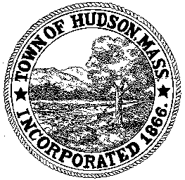

CONSERVATION COMMISSION
78 Main Street, Hudson, MA 01749
(978) 562-2020

Paul Byrne, Chairman W. Minot Wood, Vice Chairman David Esteves, Member

Terrence Joyce, Member Leif Longtine, Member Joseph Rodrigues, Member Al Tashian, Member

Meeting Agenda
September 15, 2011 7:00 P.M.

- Preliminaries
  - Open Meeting
  - Roll Call

2.0 New Business
2.1 Highland Commons Update

2.2 Gerwick Property
Ray Lyons and Susan Crane

2.2 Minutes – September 1, 2011

3.0 Old Business

4.0 Correspondence

Next Meeting: October 6, 2011

